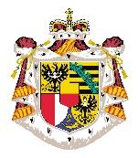
Press Office of the Princely Family
Request to download and publish photographs of the Princely Family

The Princely House of Liechtenstein reserves all rights to the photographs under this heading. The photographs may be downloaded and used for editorial purposes by news media, for display in public places, for private use and for educational purposes. However, the Princely House reserves the right to take action if it deems the use of the photographs or the manner in which they are made public to be incompatible with the dignity of the Princely House, to have a promotional purpose (advertising) or to be ideological in nature.

The undersigned requests the use of photographic material of the Princely Family:

Applicant:

Medium/Editorial/Institution:

Website:

E-Mail:

Phone number:

Intended use of the photos:

I hereby agree to use the photographs of the Princely Family only for the aforementioned purpose and to provide the Princely House with a copy of the publication in electronic form (to be sent to: office@sfl.li).

Signature of the applicant:

Date: Klicken oder tippen Sie, um ein Datum einzugeben.

